Shabbos Stories for
Parshas ha’azinu 5781
Volume 12, Issue 2 8 Tishrei/ Sept. 26, 2020
Printed L’illuy nishmas Nechama bas R’ Noach, a”h

For a free subscription, please forward your request to keren18@juno.com

The Pinteleh Yid!

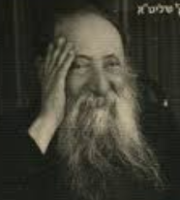
Rav Chaim Oizer

AT THE VERY FIRST Agudah Convention, HaRav Chaim Oizer, who was the Gadol Hador, suddenly stood up in full stature when a certain Rebbe walked into the room.
Someone asked Rav Chaim Oizer why he stood up for this specific Rebbe. Rav Chaim Oizer explained, “There are many who learn a lot of Masechtos in Shas ,but there is one [Talmudic tractate] that this Rebbe excels in which .מסכת ''Ahavas Yisroel, the love for a fellow Jew]'' deserves kavod (honor) This masechta is a tremendous achievement and this is why I bestowed such great honor on that Rebbe”.

IN THE TIMES OF RAV MEIR SHAPIRO, a Yid (Reb Menahem Mendel Beilis) was accused of using non-Jewish blood for matzah – “a blood libel”. They based the reason for his act on the chazal that says that Yidden are called Adam (man) and goyim (non-Jews) are not called Adam.They said that Yidden use their blood because they are not Adam .
"Rav Meir Shapiro sent a message with the defenders that they can explain to the court as follows, “When it says that Jews are called Adam ,it means that all
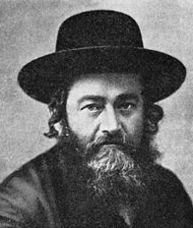
Rav Meir Shapiro

Jews together are called Adam ,since they all have such a strong connection of achdus (unity) ,and that is why they are like one Adam ,whereas the gentiles are all separate people, they are not called Adam .The proof is in this actual court-case. Look here, there is one Yid who is being falsely accused, and the entire nation is gathering to daven (pray) and help him out. If a Non-Jew would have a court case, would this be the case?

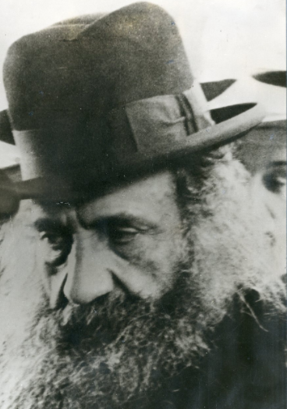
Rav Elya Lopian Rav Moshe Schneider

HARAV ELYA LOPIAN, zt”l, RELATED THE following story. In his times, one of the leading Jewish heritics made it well known throughout his life what an apikoros he was, and so he acted for many years. When he was old, he needed to have a serious operation.
Rav Moshe Schneider, zt”l, overheard the doctor telling the heretic “My friend, your life is hanging on a thread! And the operation is not at all guaranteed to be successful.”
After this, Rav Moshe Shneider heard the apikoros scream out in a booming voice, for Hashem to save him and it was these very words that he entered into the operating room with.
Rav Elya explained that all along, this brazen Jew knew that he was deceitful with himself his entire life, and it was only the layers of taiva (physical lusts) that were covering over his emunah (trust in Hashem) . Nevertheless, the moment it came to this flash of fear , and he saw he had no one to turn to, his emunah that was buried under all those layers of shmutz and his real belief in Hakodesh Baruch Hu smashed through all those layers.
The Jewish people, are Aminim ben Aminim, (Believers the sons of Believers.) If so, how is it that a person could possibly do cheit (sin) ?How could it be that a person could do something that they know is directly against the will of Hashem?
THE ANSWER IS, that deep down, in each one of us, there is something that we have, it’s called the Pintele Yid. However, because of our taivas (physical desires) ,we get blinded with layers upon layers of corruption. The Satan tricks us into make ourselves believe that it's good and causes us to sin. As the Gemara says a person only sins because of a Ruach Shtus (a spirit of folly) that goes inside of him.

Reprinted from the Parshas Ki Savo 5780 email of the Eitz Hachaim parsha sheet.

Conflicting Prophecies
By Rabbi Benyamin Adilman

The Rizhiner Rebbe once related the following story. Reb Aryeh Leib who was known as the Shpoler Zeide (grandfather) and whose home was always open to guests loved his fellow Jew with a genuine and encompassing love. As a result, within a short time after he arrived in Shpole, every Jew in town became a dedicated and pious individual.
The Shpoler Zeide had a Chassid who was very devoted. Tragically, this individual was married for many years and still had not been blessed with children. On numerous occasions he came to beseech his Rebbe (who was quite fond of him), for a blessing for offspring, yet the Shpoler Zeide rejected his request every time.
One day, the Chassid and his wife decided that enough was enough. They decided that he would go to beseech the Rebbe once more. This time he resolved that no matter what, he would not take no for an answer. He arrived in Shpole and found the Rebbe absorbed in private contemplation. He interrupted the Rebbe gently and told him the reason for his appearance.

The Shpoler Zeide told him that he was involved in a matter of great importance having to do with the welfare of the entire Jewish people, and now was not the time to accept individual petitions.

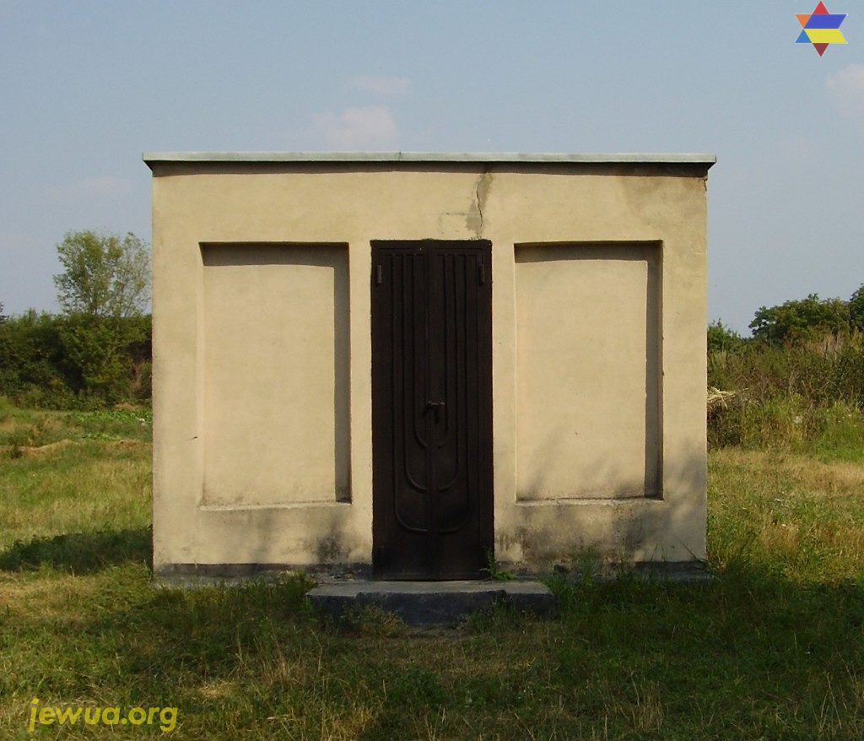
Old ohel (burial place) of Shpoler Zeide before reconstruction in 2014

When the Chassid realized the his Rebbe might actually be speaking to the Almighty face to face, he understood that this was an auspicious moment and he redoubled his efforts to gain a blessing from the Shpoler Zeide. He was so relentless that finally, with more than a trace of aggravation in his voice, the Shpoler Zeide turned on the Chassid with the full force of his presence and assured him that he would never merit having a child.
Broken, and distressed over his tragic mistake, he went on his way. If there was even a minute chance that he might have a child before, there was certainly no chance now. He absorbed himself in his business and his travel to forget his anguish.
One day he came to the town of Koretz, where the great tzadik Rabbi Pinchas of Koretz was still a young man, concealing himself in the Beit HaMidrash (study hall) so that he could engage himself solely in serving G-d.

Recognized a Person of Examplary Qualities
The Chassid had spent enough time in Shpole to recognize a person of exemplary qualities when he saw him, so he decided to get to know Reb Pinchas a bit. His further observations only confirmed his notion that Reb Pinchas was a man of great spiritual stature. The Chassid, with the hope that maybe one day Reb Pinchas could reverse the negative proclamation of the Shpoler Zeide, made a point of visiting Koretz whenever his business business took him to the general area.
Once, he arrived in Koretz a few days before Pesach. Reb Pinchas was sitting in the Beit HaMidrash, learning and praying. As usual he was destitute. Nevertheless, even the demands of the approaching holiday did not cause him to waver from his studies.
The wealthy Chassid went to the Rebbitzen (Rabbi's wife) and inquired whether or not they had the means with which to celebrate the upcoming Pesach. The Rebbitzen informed him that they had neither meat nor chicken nor fish. Not wine, not candles, not even matzah, and no prospects were in sight for obtaining any of these items.

Offered the Rebbitzen to Provide
The Needs for the Entire Holiday
The Chassid turned to the Rebbitzen and offered, "I will provide all the needs for the entire holiday if you will let me be at your Seder table." The Rebbitzen readily agreed.
When Reb Pinchas left his house the morning before Pesach, he knew that there were none of the provisions needed for the Holiday. Still, he went to pray and study like on any other day.
As soon as Reb Pinchas left, the Chassid and the Rebbitzen went to work. The previously ordered supplies began to arrive. When darkness fell over Koretz and the candles were lit, the home of Reb Pinchas was prepared for royalty. There was meat and fish and chicken.
There was the extra-strictly prepared expensive Shmura Matzah and there were wines of every type. Fresh fruits from all over the world were piled high in baskets. All the furniture in the house was replaced. The table was decked with a new snowy white cloth, new porcelain dishes, gleaming silverware, Kiddush cups and a tall candelabra.
The children and the Rebbitzen had new outfits, and a white silk Kittel was draped over the back of Reb Pinchas' chair. The family anxiously awaited the arrival of Reb Pinchas. But he, knowing that there was nothing to come home to, stayed on at the synagogue for a long while after the prayers, before finally heading home.
When he walked in the door and saw all that was before him, he was speechless. He immediately donned the silk Kittel and with great exultation made Kiddush and began to recite the Hagaddah. Reb Pinchas' exuberance was infectious and the family sang and chanted and discussed the Exodus from Egypt with great passion until finally they reached the festive holiday meal.

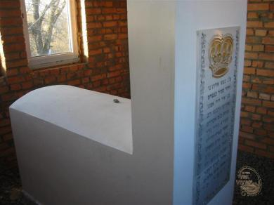
Grave of R' Pinchas of Koretz at Shepetovka
(courtesy of Agudas Ohalei Tzadikim)

Reb Pinchas turned to the Rebbitzen and asked for an explanation. She motioned to the guest indicating that he had wanted to spend Pesach with them and had provided the bounty. Reb Pinchas, still in a rapturous state, turned to the Chassid and asked him if there was anything that he could do for him.
The Chassid realizing that his chance at last had come, broke down and told the whole story of how he had been a Chassid of the Shpoler Zeide and how he and his wife had been childless for so many years, and how he never merited a blessing from his Rebbe until he bothered him about it when he shouldn't have and received the opposite of a blessing.
Reb Pinchas, being in the exalted state that he was and very moved by the man's story, replied, "If I have any merit in the Heavens at all, it is my oath that this year you will be blessed with a son!"

A Great Tumult Erupted in the Heavens
The Rizhiner Rebbe related that the moment that Reb Pinchas made his oath, a great tumult erupted in the Heavens. Here were two promises, made by two great Rebbes, and they contradicted one another. Whose would be upheld?
The Heavenly Court finally decided to examine the chronicles of the lives of each Rebbe, to see if one of them had been so cautious as to have never before made an oath or promise. They found that only Reb Pinchas had been so circumspect in his speech that he had never made an unqualified promise or oath. Therefore the Chassid and his wife were indeed blessed with a child within the year. The fame of Reb Pinchas began to spread. The Rizhiner Rebbe concluding his story said, "Despite the fact that Reb Pinchas' blessing was upheld, one must nevertheless learn from this an important lesson that one ought not go against the words of another tzadik.

The Tragedy of the False Accusations
The grandson of that Chassid was Shimshon Finkelman, who brought false accusations against Pinchas and Avraham Abba, the grandsons of Reb Pinchas of Koretz leading to their arrest and torture by being sentenced to receive 1500 blows in a gauntlet of two long rows of brutal soldiers holding a club in each hand.
The victim would have to pass between the two rows absorbing the brutal blows as he struggled to reach the end. One in a thousand survived. Most barely made it a third of the way through. Surviving was not necessarily desirable since the survivor would be sent to Siberia.
The two brothers actually made it through, but they were disfigured and mutilated in the process. They survived and were sent to Siberia. However, they got only as far as Moscow and were not able to travel any further because of their injuries. They were admitted to a government hospital where they stayed for a number of months until the Czar died and they were granted pardons.
They returned to Slovita as heroes, mutilated in body but elevated in spirit. Many Jews were drawn to them and they acquired large followings of Chassidim inspired by the Yirat Shamayim (Awe of Heaven) of the grandsons of Reb Pinchas of Koretz. Editor’s Note: Rabbi Pinchas of Koretz zt”l’s 229th Yahrzeit was Sunday, 10th Elul – Aug 30th of this year.

Reprinted from the Parshat Ki Tavo 5780 email of The Jewish Weekly. Originally printed in nishmas.org
The Lost Daughter
Of Ethiopia

Workers at Ben Gurion Airport in Israel have seen it all—dignitaries, family reunions, immigrants arriving from all over the globe. But what happened a few months ago at the Tel Aviv airport is something that no one who was there will ever forget.
More than ten members of an Ethiopian family from Ashdod waited excitedly and nervously in the terminal. They had arrived very early in anticipation of a flight that was expected that day. They had no idea of the delays and international drama they were about to experience. But they had waited for this plane for over 35 years and a few more hours would not make any difference.
Nothing was going to discourage them or dampen their spirit. You see, the airplane they were waiting for had a very special passenger on board: a daughter whom everyone had thought was long dead, having disappeared when the family escaped their Ethiopian village and began their trek to Israel.
The Unbelievable Story of Sinka Aragayi
This is the unbelievable story of Sinka Aragayi. Melekmo Yakov is a supervisor at the Israeli Ministry of Education who deals with the resettlement and education of the Ethiopian community. He immigrated to Israel in 1983 and has worked to improve the education and welfare of the many Ethiopian Jews who have since followed him there.
Due to his high-profile position, he receives many emails at work with all kinds of requests from all kinds of people all over the world. Many requests are dubious in nature, and he ignores them. But this one was different.
“A few months ago,” he starts to explain, “I got an email from a woman who wrote to me, ‘I am a lost Jewish girl, and I am looking for my relatives in Israel.’ It was written in Amharic, the language of Ethiopia.” That was not common. He made some enquiries among members of the Israeli Ethiopian community and discovered that others, too, had received similar emails. “I was about the fiftieth person she wrote to.

No One Had Responded
No one had responded. Over the past four years, members of the Knesset, journalists and others had received similar emails. Somehow she got my name as well.”
Melekmo didn’t think much of it either. But a week later he received another email from the same woman. This one was more intriguing: “I was a Jewish girl lost in Sudan at the age of 14 in 1983, and I expect an answer.”
This time Melekmo had reason to consider it. “Every year on Jerusalem Day there is a memorial on Har Herzl for all those who perished in their attempt to immigrate to Israel. I have been going there for 20 years, and I translate the speeches from Hebrew to Amharic.
Likewise, on Sigd [an Ethiopian Jewish holiday celebrated 50 days after Yom Kippur], I lead the state commemoration. “Every year at that ceremony, many Ethiopians who immigrated to Israel come up to me at the end of the even about the children they lost through kidnapping, confusion and illness during their journey. The stories really hurt me. You see the tears and pain. But what can I do? It got me thinking that maybe this woman’s request was true and that she was one of those lost children.”

The Woman was Alone in a Foreign Country
Then he got a third email. The woman explained that she was alone in a foreign country, with no idea where her family might be or even if any family members were alive. She felt depressed and helpless. She had done everything possible to find her family, and Melekmo was her last hope.
After three emails, Melekmo felt the need to respond. He wrote to her, telling her honestly that although he was skeptical about her story, he was willing to hear from her. She replied immediately. She said her name was Sinka Aragayi. She had been in Canada for four years after spending the previous 30 years in Sudan, where she kept her Judaism a secret. She had no means of contacting anyone while she was in Sudan. Upon being granted asylum in Canada, she immediately set about trying to find out what had become of her family.
She was from the Beta Israel community in Ethiopia. On the day that her family received approval to begin their trek to Sudan, 14-year-old Sinka was attending a class with the Israeli government representative in her village. When she got home, she found a note stating that her family had already left and would meet her at a certain staging point on the trail to Sudan.

In the Darkness and Confusion, the Young Girl Got Lost
But in the darkness and confusion, the young girl got lost and never found her family. After reading this account, Melekmo’s wife urged him to ask Sinka for a phone number so that he could speak to her and clear up or confirm any doubts he had. Sinka sent a number and Melekmo called.
He grilled her for more details: What village was she from? Who were her parents? When he asked her to confirm if she was truly Beta Israel, she replied with the special word for “Jew” that only the local Jews knew. And that is when he believed he was dealing with a true daughter of Israel. A non-Jewish Ethiopian would not have known this secret code word, which they used only among themselves.
“One week later, I called her again and went over all the questions I had asked her before. I wanted to make sure all her answers matched, sort of a test to make sure she was telling the truth.” Her second story was identical to the first. “I said to myself, she is one of ours, from the community,” Melekmo said.
At that point Sinka gave Melekmo the name of her brother David, and some information only she and her family would know. Melekmo began his search for Sinka’s family. Melekmo kept his word and began to look for Sinka’s family in Israel. “I started searching, asking well-known members of the community.
“Many tried to dissuade me. They said they had heard of the family I was searching for but did not know where they were. They advised me to leave them alone. The family had already mourned for their daughter and had even sent envoys to Sudan, who repeatedly told them she was dead.”

No One Thought She Could Have Survived on Her Own
It was easy to believe Sinka was dead. Everyone was leaving Ethiopia in that busy period. With unstable borders, shaky diplomatic negotiations and an airlift that needed to keep to its schedule, the rest of the family had little choice but to depart to Sudan, and then to move on to Israel, without Sinka.
Though they prayed for her safety, there was little chance she could have survived in that hostile environment on her own. Melekmo was not deterred. He spoke with a journalist from a radio station in Ethiopia. Over the years many Ethiopian Jews had submitted names to the station for broadcasting in the hope that a missing relative might hear it and respond.
He perused the list and found Sinka’s uncle’s name; the uncle had called in many years ago searching for her. Though the list was outdated, the journalist was able to contact Sinka’s uncle, now 90 years old, in Israel and inform him of the news.

Is My Sister’s Daughter Really Alive…?
The uncle, it turned out, remembered Melekmo’s family from their years in Ethiopia and called him that same day. “Your father was a reliable man. I trust you are as well,” the uncle began cautiously. “Is it true what the reporter in Ethiopia is saying? Is my sister’s daughter really alive in Canada?”
Melekmo answered that she was indeed alive, and the line went dead. A few minutes later the phone rang again. The old man’s son was on the line; he told Melekmo that his father had fainted. When the uncle got back on the phone, he told Melekmo through tears of joy that Sinka’s mother had never given up hope. She had gone to the Kotel every Monday and Thursday, praying for her daughter to come back.
Melekmo called Sinka right away. “She was at work. I told her that I had found her mother and uncle living in Israel. The line went silent. A co-worker got on and told me that Sinka had collapsed.”
They soon set up a video telephone call to reunite the mother in Israel and the daughter in Canada. The emotional impact of that virtual reunion is indescribable. It was time to bring Sinka to Israel. The government made its investigation, establishing that Sinka was Jewish and eligible to make aliyah.
But then bureaucracy stepped in. Though she had been granted asylum in Canada, Sinka had no official papers, no passport, and no citizenship. Government ministers Gideon Saar and Avigdor Liberman worked out the necessary temporary paperwork so that she could come to Israel.

Arrested in Istanbul, Turkey
Sinka was on her way. Or so she thought. Her flight from Canada had a stop in Turkey. In Istanbul, she was arrested and taken away in handcuffs. Her Israeli-issued documents were not in order, they said; there were “inconsistencies.”
Meanwhile, Sinka’s relatives and Melekmo were already at Ben Gurion, awaiting her arrival. When they were informed that Sinka had been arrested in Turkey, they felt true despair. Their wait into the night began. While Israeli officials were trying to sort things out with the Turkish authorities, an Israeli man who was passing through the Istanbul airport saw Sinka and recognized her from the report and picture in the newspaper he was carrying;
Sinka’s story had become quite newsworthy in Israel. In an amazing instance of divine providence, this man was able to approach the Turkish officer who was guarding Sinka, explain who she was, and emphasize why she must continue on her long-delayed journey to Israel.

Put on the Next Plane to Tel Aviv
The Turks corroborated the story with the Israelis, and Sinka was released and put on the next plane to Tel Aviv. Her brother, nephews and other family members waited patiently for the plane to arrive and pull up to the gate. Their powerful emotions when she stepped off the jet way cannot be put into words. After over 30 years of grief, privation and misery, Sinka Aragayi had rejoined her family in Israel. Her 96-year-old mother was waiting in Ashdod. The family pulled up there at five a.m. Needless to say, her mother had not slept at all. She said, “How can I sleep? Hashem heard my prayer and brought me back my daughter.”
Melekmo stood in the back, unobtrusively watching the reunion. “How will I ever forget watching this lost girl see her mother again after more than 30 years, watching a mother’s heartfelt prayers answered? Pesach soon followed.
The entire family gathered for the Seder, and the themes of exile, exodus and return were not lost on them. During the holiday the family went to Jerusalem together. At the Kotel, where Sinka’s mother had cried and prayed for decades for the return of her lost daughter, her daughter now cried tears of joy. At long last, she had returned to her family and to her people

Reprinted from the Parshat Ki Savo 5780 website of Hidabroot.com

Back in the U.S.S.R.

In the 1970s, a Red Army school inspector questions a boy in class.
“Who is your father?”
“The Soviet Union.”
“Who is your mother?”
“The communist party.”
“And what do you want to be when you grow up?”
“I want to be a worker for the glory of the state and the party.”
The inspector then points to one of the girls.
“Who is your father?”
“The Soviet Union.”
“Who is your mother?”
“The communist party.”
“And what do you want to be when you grow up?”
“A heroine of the Soviet Union raising many children for the state and the party.”
The inspector spots a Jewish boy in the back of the classroom trying to lay low.
“What’s your name?”
“Shmuly Rabinovich.”
“Who is your father?”
“The Soviet Union.”
“Who is your mother?”
“The communist party.” “
And what do you want to be when you grow up?”
“An orphan.”

Reprinted from the Parshat Ki Savo 5780 email of Lekavod Shabbos

How Much More
Must We Endure?
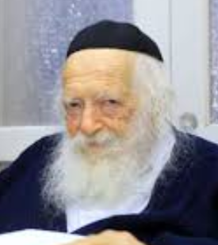

Many people would regularly gather at the home of Rav Chaim Kanievsky, Shlit"a, in Bnei Brak, to seek his advice and Brachah.
Once, a man turned to Rav Chaim and asked, “How does the Rav explain the troubles that Klal Yisroel is facing? For many years I have been involved in Chesed activities and never do I remember a time during which Yidden have been plagued with such troubles. How do we explain this?”
All those present turned to Rav Chaim and awaited his answer.
“It is well known,” said Rav Chaim, “that during the generation of Moshiach, HaKadosh Boruch Hu will clean out the generation of its Aveiros (sins) and purify us in order to greet Moshiach. How does Hashem clean us of our Aveiros? With Tzaros— troubles and hardships. That is the reason for today's predicament.”
One of the people in the room asked Rav Chaim, “But Rebbe, until when? How much more must we endure?”
Rav Kanievsky closed his eyes and told those assembled, “Believe me, we are already near the end. We are really near the end…”

Reprinted from the Parshas Devorim 5780 email of Torah U’Tefilah as compiled by Rabbi Yehuda Winzelberg.

The Unexpected Daf
Yomi Participant

In 1987, Rabbi Yosef Karmel, former director of Camp Agudah Midwest, invited Rabbi Eliezer Levin, O”BM, one of America’s oldest and most revered rabbis, and his son Rabbi Avraham Chaim Levin, O”BM, dean/founder of the Telshe Yeshiva in Chicago, to camp for the weekend. This was obviously a tremendous occasion for the campers, and the spiritual energy was off the walls. After Shabbos davening, Rabbi Karmel announced that while the campers would attend their regularly scheduled learning classes, Rav Avraham Chaim Levin would teach the Daf Yomi to the lay guests who had come to vacation that weekend together with the camp and the distinguished visitors.
As everyone dispersed from the Shul, Rabbi Karmel felt a soft tap on his arm. It was Rav Eliezer Levin, who wanted to know where Daf Yomi class would take place. Rabbi Karmel figured that it would be improper for him not to attend the class along with other guests, and that the great Rav was about to sacrifice an hour sitting in a class geared to lay people, all in the name of good manners.
R’ Karmel reassured Rabbi Levin: “There’s no need for you to attend this shiur; it’s meant for laymen and no one expect the Rav to come.”
The elderly Rav looked at Rabbi Karmel with incredulity and said: “What? Do you think I would miss the chance to hear my son teach a blatt Gemara (page of the Talmud)?

Reprinted from the Parshas Eikev 5780 email of the Torah Sweets Weekly email.

